Georgia State Parks and Historic Sites
Weekend Summary
07.20.2020

Crowds:
- Extreme heat has been a factor again this week, affecting day use visitation and park staff are responding to increased heat related first aid calls. Sites that had to temporarily limit day use access due to capacity include: Cloudland Canyon, Vogel, Tugaloo, and Red Top Mountain.

- Golf Course activity was 29% over last year this past week. The heat did deter golfers compared to the previous weeks at the golf courses. However, play was high at Brazell’s Creek at Gordonia bringing in over $5,500 this weekend. Crooked River and Red Top had the most boating activity over the weekend.

- Victoria Bryant staff dealt with a group of 20 people not social distancing and congregating at the Rice Creek sliding rock area. DNR/LED worked with the Red Top Mountain staff to disperse approximately 20 people at the Bethany Boat ramp who were blocking the boat turn-around and not following social distancing guidelines. Cloudland Canyon staff reminded guests to avoid congregating and swimming at the falls. The museum at Wormsloe has been reaching capacity daily by mid-day and Fort King George has experienced several large family groups which affects managing the building capacity.

Staffing issues:
- As of Monday, the Division has 29 part-time and full-time staff out due to COVID-19 related reasons. Hard Labor Creek, Mistletoe, and Richard B. Russell are working through COVID staffing related issues. These sites have had coverage from other sites and are hoping to have several employees return this coming week.

Positives
- Jarrell Plantation reopened all areas of the site after tornado damage repairs were completed.
- Etowah Indian Mounds saw strong visitation with over 175 admission tickets sold over the weekend.
- Work is progressing with the walls framing in at new interpretive center at Skidaway Island.
- Black Rock Mountain filled two housekeeper positions after extended vacancies.
- Website Statistics continue to be high. This past weekend total pageviews were up 68% with 1.26 million views this week. Reservation pageviews were up 75% and the Alerts Page received 13,863 pageviews.
Challenges
- Indian Springs had a RV camper flip while entering the park. No major injuries occurred.
- Watson Mill staff and local emergency responders assisted a guest with a prior medical AFIB issue.
- Fort Yargo staff and local responders assisted an 8-year-old girl who stepped on coals near a grill on the ground.
- Tugaloo had a theft from a ParkPass box break-in.
- At Black Rock Mountain a tree fell and pulled a power line down, barely missing a camper who was able to safely move to another campsite.
- The U.S. coin shortage has been a challenge in some sites.
- George L. Smith had a guest with a cat and a raccoon in a cottage. LED was notified due to raccoons being a rabies vector species and the guest left and forfeited her remaining two nights to cover pet fees and additional cleaning fees as she was not in a pet friendly cabin.
- General Coffee has experienced an increase in day use and after-hours issues because the City of Douglas started actively enforcing COVID-19 guidelines. This weekend a group of teenagers were assisted out of the closed pioneer camping area.
- A debris pile at Fort McAllister caught fire Sunday, possibly due to hot ashes being dumped on it. Permits were quickly obtained, and the pile burned without incident.

Financial Update
Past Weekend:
Overall occupancy for all reservables increased 7% this past weekend to 71%. Camping increased 8%, reaching 79% occupancy. Yurts were at 100% occupancy, 19% higher than the previous year. Cottage rentals slightly declined by 1% to 89% occupancy.
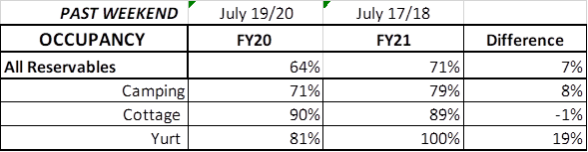
Upcoming Weekend:
For the upcoming weekend, there is a 1% increase in all reservables at 67% occupancy. Camping is showing a 5% increase, while yurts are showing a 4% decrease and cottages a 1% decrease.
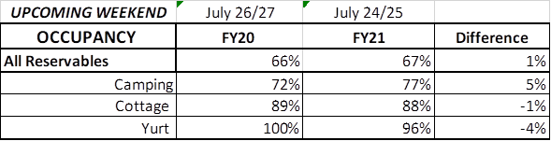
Revenue:
This past week, July 13 – 19th, there was a 1% increase or $10,776 in overall revenue. For overnight accommodations – camping revenue continues to significantly increase. This past week camping revenue improved 23% or $51,000. Cottage revenue also increased 3% or $8,000, the first increase in cottage revenue in the past 3 weeks. Yurts improved 82% or $8,000.

This past week, ParkPass revenue increased 27% or $29,000 compared to last year.

Golf was up 29% this past week or $11,000.

Historic site admissions declined in comparison to last year by 12% or $6,000.

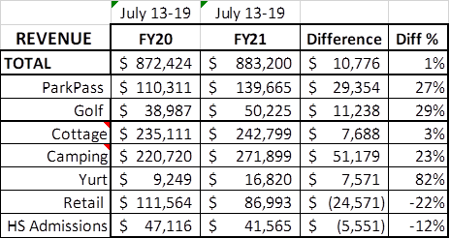

Cancellations/Refunds:

During COVID19, there have been 39,000 reservation cancellations, including $3.5 Million in actual refunds and a loss of future revenue of $16 Million. This is 1,000 more than last Monday with 38,000 cancellations. For the first time since COVID began, the cancellations are the same as the previous year, with 1,000 cancellations last year during the same time period.

Last year during March through YTD, we had 16,000 cancellations, including $828,000 in actual refunds and a loss of future revenue of $4.0 Million. So, total cancellations have increased over 23,000 or 143% and the amount of refunds have increased $2.7 Million.

